Multistep Form:
We have the form for that form I am taking the data manually
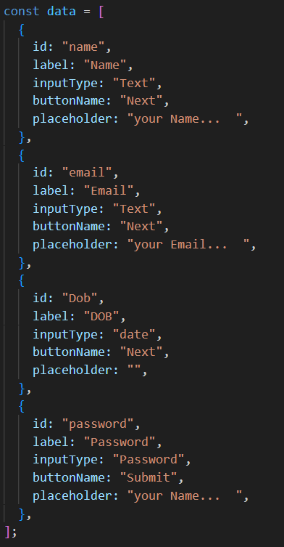]
We have the index and the forms index to get data sizes and forms to access the data
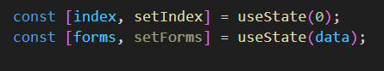
We have the handle submit and the handle back functionality in the handle submit if the form length is equal to last then I need to give alert and set index to 0 to go first page.
In the handle back page I am decreasing the index step by 1
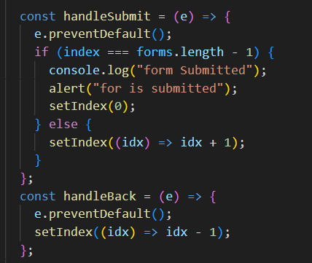
This is the form and inside the form we are passing the data and making it to access and adding the back button based on the index
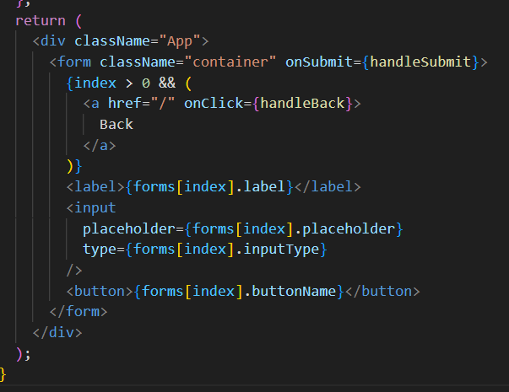
14.23 min stopped

